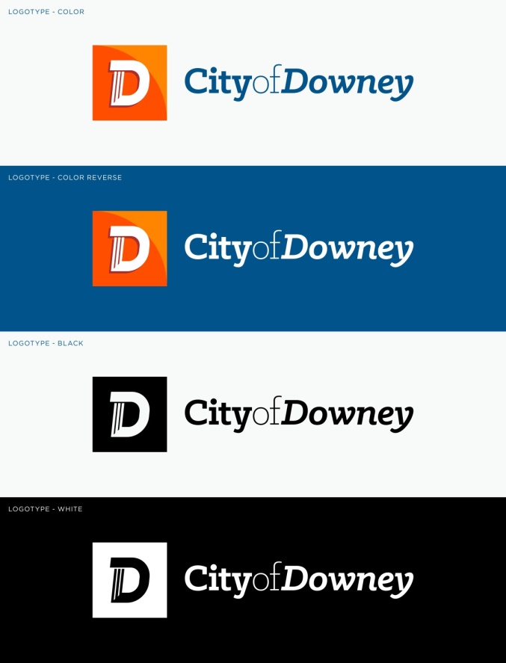

• Transit Services

8150 Nance Street, Downey, CA 90241

**Public Notice of Rights**

**under Title VI of the Civil Rights Act**

In keeping with the City’s tradition of community and involvement, Downey Transit Services is committed to ensuring that **no person is excluded from participation in, or denied the benefits of its service on the basis of race, color or national origin** as provided under Title VI of the Civil Rights Act. In addition, Downey prohibits discrimination based on sex, age, disability, religion, sexual orientation, gender identity, and other protected classes enumerated in federal and state laws.

If you have any questions about the Title VI Civil Rights Act or would like additional information on Downey’s obligation regarding non-discrimination, please visit the Title VI Nondiscrimination & Language Access Plan page on the City website or call (562) 299-6619.

If you believe you have been discriminated against, you have 180 days from the date of the alleged discrimination to file a signed, written complaint. The complaint should include the following information:

* Your name, address, and how to contact you (i.e., telephone number, email address)
* How, when, where, and why you believe you were discriminated against. Include the location, names, and contact information of any witnesses.

A full description of the Complaint Process and complaint form is available on the Transit section of the City’s website or at the Transit.

The complaint should be filed in writing with:

Downey City Manager’s Office

11111 Brookshire Ave., Downey, 3rd floor

(562) 299-6619

You may also file a Civil Rights Act Title VI complaint with the FTA at:

U.S. Department of Transportation

Federal Transit Administration

Office of Civil Rights

Attention: Complaint Team

East Building, 5th Floor – TCR,

1200 New Jersey Avenue, SE,

Washington, DC 20590

제목 VI 에 따른 권리 공시

다른 언어로 정보를 제공받으시려면(562) 299-6619 로 연락하십시오